***Team Bandomeer – Java Basics Teamwork assignment***

**Game: Minesweeper**

* Very popular casual game
* A single-player video game - the object is to clear an abstract minefield without detonating a mine

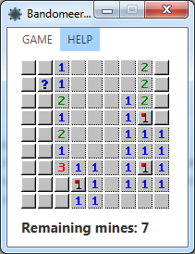 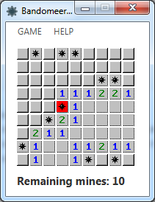

**PROJECT STRUCTURE**

* Object-oriented programming in all its glory
* 3 groups of classes:
  + UI related – folder ‘views’, JavaFX lib used for the UI
  + Game logic related – folder ‘models’, contains classes for the cell and game board behavior
  + Linking the game logic with the UI – folder ‘controllers’
* The work was distributed amongst team members according to those 3 groups of classes
* The result is scalable board size and amount of mines, any aspect of the game can be modified easily without influencing the behavior of other game elements

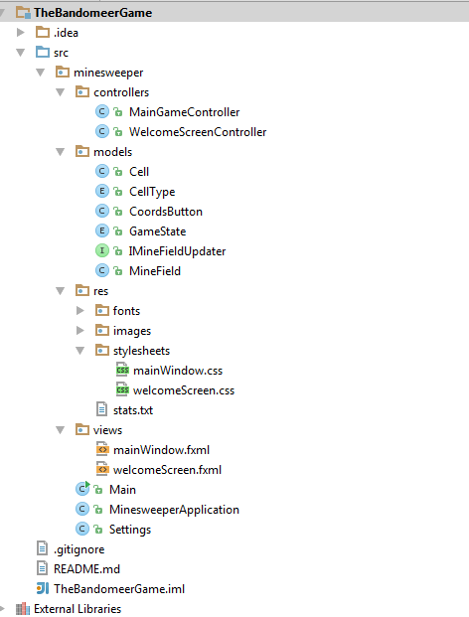

TEAM BANDOMEER © 2014

YORDAN DARAKCHIEV - Lead Programmer (UI and its link to the game logic, mentoring all aspects of the project)

VELIKO DIMOV - Additional Programming (Game logic)

DIMITAR DIMITROV - Additional Programming (linking the game logic to the UI), Game design, Project presentation

MIHAIL YOTOV - Additional Programming (Game logic), QA